The Four Pillars of OOP
Great video demo on these: https://www.youtube.com/watch?v=j0lBrYSlYaU

- Classes and Objects are both major components of Object Oriented Programming (OOP). The name “OOP” implies programming oriented around objects… but what does that mean exactly?
  - OOP is a philosophy that urges us to write code that uses objects to fill certain roles and responsibilities. Imagine an online banking service:
    - User logs in -> Create a User object that stores data about the logged in user in its variables. Imagine that the User Class has methods for deposit() and withdraw().
    - User makes a deposit -> Create a Transaction object, with variables like amount, account_number, etc. to add money to the desired account
    - Confirmation gets sent -> Create a Receipt object with the transaction-relevant info to save to a database, email to the user, etc.
      - Remember all of these hypothetical objects are based off of Classes that you would write preemptively as you plan ahead for what objects you’ll need and where they’ll be used

  - OOP moves us away from the simple top-down structure of a simple script, often resulting in more powerful code that’s still relatively simple and clean.
    - Keep in mind - a simple script is better sometimes. If you just want a quick report generator, you may not need any objects at all.

- There are 4 Pillars of OOP which serve as guidelines and rules for writing clean, organized, maintainable object-oriented code. They are:

1) Abstraction

- Abstraction is the practice of hiding the implementation details of a method from the user/developer, so that they can focus on behavior, as opposed to how it’s actually working under the hood.
  - For instance, the user only needs to know what the Math.random() method does. You don’t need to know how the Java devs actually coded the functionality of that method. The goal of abstraction is cleaner and more readable code.
    - Microwave example - you don’t need to know what’s behind the touchpad, what makes the plate spin, or what releases the heat. ALL you need to do is press buttons and wait.


“I have no idea what’s going on… and that’s ok!”

2) Encapsulation

- Encapsulation is the practice of keeping an object's data protected and only accessible in controlled ways.
  - In Java, we accomplish this with private variables. Then we allow access to these fields through getter and setter methods.

- Encapsulation is good practice because it prevents accidental access or changes to the data. A well-encapsulated application only allows access to the data through very specific avenues.

Here’s a very barebones example (JUST showing the field and getter/setter)
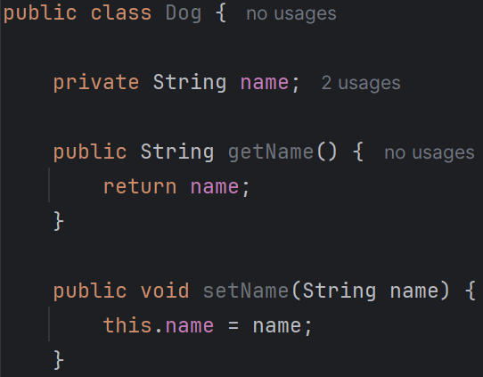
3) Inheritance

- The process where one entity (class, interface) takes on the properties (members. fields/methods) of another entity. The key here is code reuse and specialization.
- Say we have an Animal class. We also have a bunch of other classes that extend the Animal class. By extending the Animal class, all of these other classes inherit its members, thus sharing a bunch of Animal attributes.
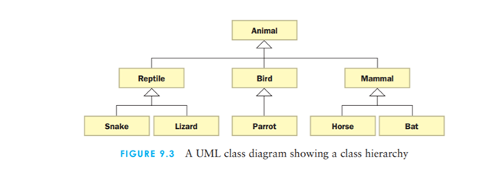
- Primary examples of inheritance in Java are extending Classes, and implementing Interfaces

4) Polymorphism
- The ability of something in Java (usually classes/objects/methods) to take on many forms. The name actually comes from Greek “Having multiple forms”.
- So when we have classes extending from the Animal class, that’s the Animal class taking on many different forms. See the diagram above. (Every class that extends Animal IS-A Animal.)
Inheritance and Polymorphism have a lot of overlap, which confuses some people. It helps to remember that Inheritance is THE PROCESS of a child class inheriting it’s parent’s members. The ability to do this is an example of Polymorphism.

- Method overloading/overriding are other very common examples of polymorphism
  - Different “forms” of the same method
  - Overloading - methods with the same method name but different parameters.
    - Example: Having multiple constructors in one class
  - Overriding - methods with the same method signature but different implementations (method bodies).
    - Example: Child Class changing the behavior of a Parent Class’s methods with @Override
- Inheritance is object-based polymorphism
- Overloading/Overriding is method-based polymorphism

